The Romance of Melsetter  __________  REMOTE RHODESIA NAMED FROM  THE ORKNEYS  __________  .  By Mrs. Tawse Jollie, M.L.A.  In this article, Mrs. Tawse Jollie, the only woman member of Parliament in Rhodesia, and thus in all South Africa, writes of the hardships and high endeavours of those early pioneers who trekked from the South, being sometimes 18 months on the way, to secure Rhodesia’s eastern flank. Partly Dutch and partly English, these early Rhodesians were led by a Scot who named the district after his old home in the Orkney Islands. | 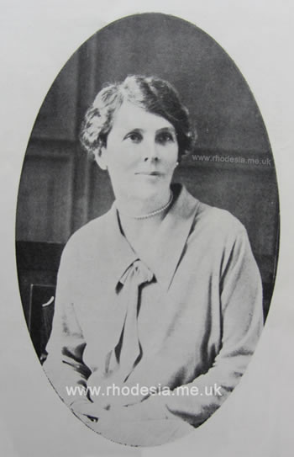  Photo by E.M. Kennedy  Ethel Tawse Jollie M.L.A.
.

On the eastern border of Rhodesia, between the Portuguese frontier and the Sabi and Odzi rivers, lies a long, narrow strip, shaped rather like a pear with its stalk tapering to the south, known as Melsetter. Twelve years ago when I first came to the Colony it was an almost unknown region to most Rhodesians. The journey from Umtali, performed in a prehistoric post cart, was not to be lightly or unadvisedly undertaken. During the rainy season a delay of days or even weeks was possible. Donkey wagons (because of African Coast fever restrictions on ox transport) crawled slowly over the heavy mountain road which was then our only means of approach, and we reckoned on at least three or four months every year in which they could not cross rivers. Even as late as 1925 our mail service was interrupted for several weeks, and we had no wagon with supplies between December and the end of March.
Little wonder, therefore, that this country was regarded as the back of beyond, and that those of us who deliberately chose to live here were considered by our friends to be rather mad. Yet one visitor of discernment recorded the fact the inhabitants of Melsetter district regard those of the rest of Rhodesia with something like pity. It is true. Nowhere have I found a more ardent local patriotism and more than one casual visitor has caught the infection, while Government officials, coming here against their will, have ended by buying farms and settling in our midst.
Mountain and Valley.
Now that there are two roads into the district, one of them over the mountains and the other along the Sabi and Odzi valleys, while the rivers are provided with drifts and low-level bridges, Melsetter district is rapidly becoming a tourist resort. Every year more and more people come here, especially during the winter months, to enjoy our beautiful and romantic scenery, our many lovely streams and our delightful climate. Few of them, however, realise the romantic history lying behind the settlement of this district.
A great deal of Melsetter was once part of the native territory of Gazaland – a name meaning the place of blood – and this territorial title is still used. The paramount chief of this region at the time of the occupation was Gungunyahna, who was a relative of Lobengula, and a nominal vassal of the Matabele king. In the Seventies of the last century the Jesuit fraternity obtained from Lobengula permission for two fathers to travel to Gazaland with the idea of founding a station, and these unfortunate men, who had only just arrived from Belgium, started out along the old hunters’ road from Lobengula’s kraal, now known as Bulawayo. Deserted and robbed by their native servants as soon as they parted company with the other travellers, it is wonderful that one of them struggled on until he reached the kraal of Umzila, who was Gungunyahna’s predecessor. This spot is about 17 miles from where I am writing.
Some years later a party came in from the east and were told of the Jesuit father’s death and burial. They, too, paid toll with the lives of one or two and the survivor reported that the country was unfavourable to mission enterprise. Even while he wrote, however, an American mission was planning an expedition under experienced African travellers, and as a result, among the earliest pioneers of the district were the founders of the Mount Selinda Mission, close to what was Umzila’s kraal.
.
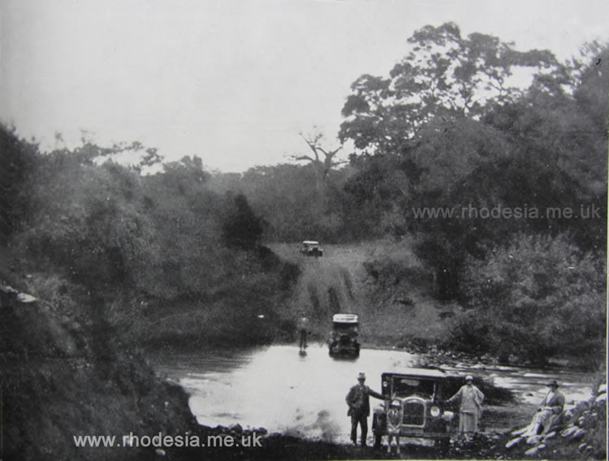
Photo by A. Howat
Crossing the Tanganda River on the Sabi road from Umtali to Chipinga.
.
Hunters of the Middle Veld.
The earliest written account of any part of the district is found in a book called “Les Pères Jesuites dans le pays d’Umzila,” which consists of letters from the Jesuit father I have referred to. This was published in 1976, and is really a report to the Superior of his Order in Belgium, and is, of course, written in French. In or about 1880 appeared another book called “Through Gazaland,” written by a hunter named Gillmore, who started from Delagoa Bay and, working northwards, reached Manicaland. His description of the “Savannah Country,” as he calls the middle veld, and of the streams and valleys, is as accurate to-day as when it was written, but his map and ideas of geography generally are vague and he gives neither dates, distances nor proper names. Beira is not marked on his map and he evidently crossed the Sabi once but never discovered that it makes a right angle in its course from the north. Another hunter, Anderson, who published a book of African travels in 1888, knew even less of the geography of this region, and the only place named on his map is “Umzila.”
Gillmore’s description of wild game makes the mouths of sportsmen water. There is still good hunting across the border in Portuguese territory and along the Sabi Valley, but even in my own remote home which is almost on the Portuguese frontier and far to the south we have arrived in the last year or two at the point of getting a regular supply of beef and mutton from a butcher.
Gillmore’s account of the tractable and cheerful nature of the natives is also correct to-day and he knew they are partly the same race as the Matabele and the Zulus. One branch of the invasion which conquered Matabeleland came here and settled among the indigenous natives and the language spoken is a Mashona dialect, but the older men can almost invariably understand Sindebele or Zulu. These people call themselves Shangaans and though I believe the true Shangaan country is to south, all the natives in my part of the district, who despise the Mashonas and Manyikas, claim to belong to that race, which is the result of the invasion of warriors who took wives from among the conquered tribes. In type they vary so much as to suggest a very mixed origin and many are of a light copper colour. As the Arabs had much intercourse with Eastern Mashonaland in historic times and as there must have been traffic in gold across part of this territory at an earlier period, it is not, perhaps, fantastic to trace (as I often do) features of an Asiatic rather than of a negroid type. We have some old workings and ruins and other traces of the prehistoric occupation in different parts and the presence of lemons, Seville oranges, and other non-indigenous trees, growing wild, suggests that this region also shared in that long-forgotten occupation which left rock mines and the Zimbabwe.
.
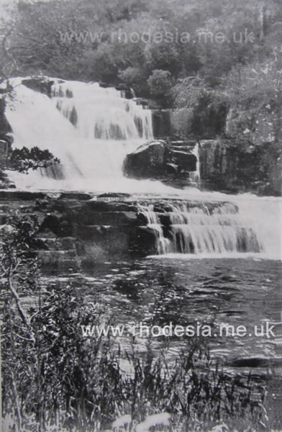
Photo by Mrs. M.H. Coleman
Silver Stream, Melsetter
.
A Page out of History.
But the scanty records or relics of these days are not our only romance. The history of the occupation of the ‘nineties reads like a page out of a much earlier period of South African history. When Rhodes sent the Pioneer force into Mashonaland and obtained the concessions in Manicaland (where the Portuguese, American and British prospectors were already at work) he found Portuguese eyes on the eastern flank of the territory. As soon as the eastern escarpment is reached the climate is as healthful as any in Rhodesia, and the country is beautiful and fertile. It was a race to get there. The pioneers were looking for minerals, and Gazaland was a long way off and had no such obvious signs of previous mineral development as other parts of Mashonaland, so Rhodes offered pioneer farms to farmers in the Transvaal and Free State and accordingly several “treks” took place.
These migrations of whole families with wagons and cattle and all worldly possessions are characteristic of Africa and the Boers. Months, and even years, have been spent in this leisurely travel, and some of the Melsetter settlers actually had no home but their wagons for more than eighteen months. The leader of the first trek, who had made a previous reconnaissance, was named Dunbar Moodie, and it was he who christened the district Melsetter after the old home of his family in the Orkneys. The settlers were both English and Dutch, but the latter seem to have stood the pioneer conditions best, for although three or four English families still remain who came with these early treks, and their children are now living here and bringing up families, yet many of them left.

Life must have been incredibly hard. The natives did not want to work for the newcomers and their sons and daughters had to herd and hoe and drive the oxen. Wild animals abounded and though plentiful game was an advantage, the presence of lions and leopards was not. All provisions and materials had to be brought in over the mountains, from Umtali, a distance of 100 to 150 miles. The settlers came in from the south over the Limpopo and Sabi but it was the kind of route that was never retraced. Only recently we are beginning to use it again with the help of oxen to take cars across a drift on the Sabi and good roads on either side. At one place on the south bank of the Tanganda the climb was so steep that each wagon had to inspan three teams of oxen, but to-day a donkey wagon climbs the “Three Span Berg” with ease, and cars “do” it on “second” and most of it on “top.” Nevertheless, there are many pioneers living in the district who have never moved more than a few miles from the spot where they settled after their long trek from the South.
.
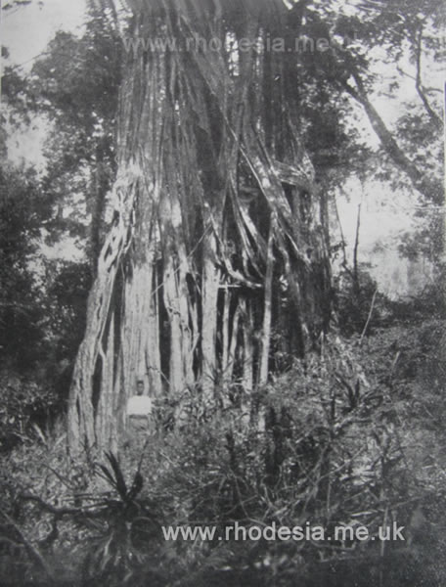
Photo by A. Howat
In Mount Selinda Forest, Melsetter -
the parasite Fig which covers the giant trees and finally kills them.
Holidays at the Hot Springs.
An interesting recent development is the opening of the Hot Springs Camp. Close to Sabi road, some sixty miles from Umtali and the same distance from Chipinga, a hot mineral spring wells up – this one of five or six along the valley. A rest camp has now been made there where visitors can spend the night or longer if they like and get food and lodging and bathe in screened pools specially dug out. Although analysis does not reveal and special curative properties in the water, which is only slightly impregnated with sulphur, yet the experience of many of my friends and neighbours goes to prove that these baths do good to rheumatic patients, and people come from Umtali and even further off to try them. As these springs are numerous all along the valley, they have been well known to the residents for a long time and have afforded the pretext for many family picnics lasting several days, which took the place, in our isolated district, of a the periodical visit to the coast which other Rhodesians enjoy.
Along the Sabi road, if one is lucky, wild game of various kinds may be seen and shot – baboons, koodoo, impala and many other buck. A few weeks ago a new settler who was bringing his wife and family from Umtali in a motor lorry saw six lions cross the road, of whom one ran along for some distance in front of the car, dazzled probably by the lights, as it was night time. Four of them have since been accounted for.
One of the great attractions of the district is the Mount Selinda Forest, a tract about three miles long by one mile broad which lies on the south, almost the southernmost point of European occupation. To eyes accustomed to African conditions, with comparatively poor timber, this forest must be a revelation. There are real giants in it, one in particular which is 218 feet high and 52 feet in circumference at a height of nine feet from the ground. But the great beauty of the forest lies, to my mind, in the extraordinary contrast between the country outside – a brad, open, rolling grassy country – and the cloistered seclusion into which one steps, as through a gate, the moment one enters it. The trees taper up straight and smooth, to an almost incredible height, and their canopy of leaves makes a dim shade in the aisles of this natural cathedral. The undergrowth is light and graceful, the paths edged with mosses and ferns, and despite the luxuriant vegetation the forest resembles those of Europe rather than the rank and very often miasmic-looking growth of tropical countries.
One would have imagined that this unique piece of timber, probably the last remains of primeval forest in Southern Rhodesia, would have been set aside as a national possession, but it was alienated in the early days, part to the American mission of Mount Selinda, and two other parts to farmers whose land adjoins it. Fortunately, all three owners are anxious to preserve such an asset, and although a good deal of valuable timber has been cut, there is no waste or wanton destruction and care is taken which is actually improving the condition of the trees.
Gillmore, writing nearly fifty years ago, declared that of all countries he had seen in his world-wide travels none was more attractive or seemed to offer greater possibilities than this. He spoke of cotton, tobacco, tea and coffee as possible crops, and to-day we are still looking to these to pull our district out of the difficulties caused by our geographical position.
The romance of pioneering is more readily appreciated by those read than by those who live it, but, in these days, when the Colony is rapidly passing from the pioneer stage to one in which motor cars and trips to “town” are a feature of country life, it is still possible, in Melsetter, to hear stories of adventure and endurance from those who have lived to see the wild country tamed, jungle turned into pasture, and forest into ploughed lands. And it is an unimaginative person who cannot find in the growth of a civilised community out of such unpromising conditions the thrill of the Canadian rhymer who wrote:-
“It rarely stirs the blood
To see cities in the bud
And to feel a nation growing
From the sticky prairie mud!”

The above article was first published in 1927.
.
The district then described as Melsetter by Mrs Tawse Jollie included what we would subsequently come to know as the Chipinga district.
Mrs Tawse Jollie in fact lived on her homestead, Chibuzana, which is near the Moçambique border East of Chipinga but was then known as South Melsetter district.
.
The letters M.L.A. stand for Member of the Legislative Assembly.
This designation was later changed to MP, for Member of Parliament.
.
Those wishing to learn more about life in Rhodesia during the 1920s would do well to read "The Real Rhodesia" by Ethel Tawse Jollie which was published in 1924 shortly after Rhodesia was granted responsible government (for which she actively campaigned). The book was also republished in 1971 by Books of Rhodesia and copies may frequently be found for sale.
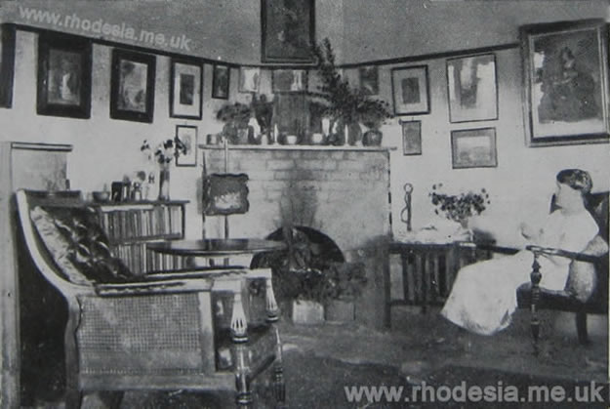.
Mrs Ethel Tawse Jollie's homestead, Chibuzana, near Chipinga, showing the sitting room.

..
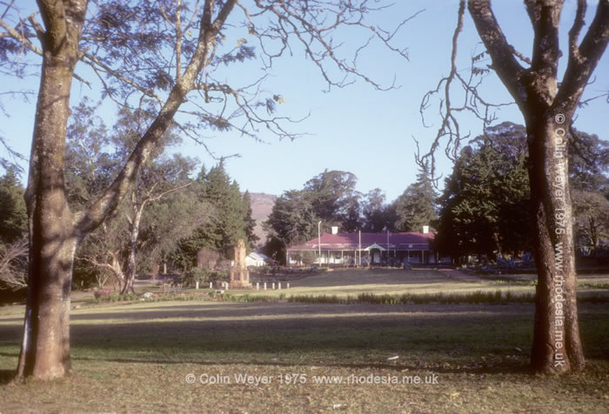
Melsetter showing the Pioneer Memorial on the village green.

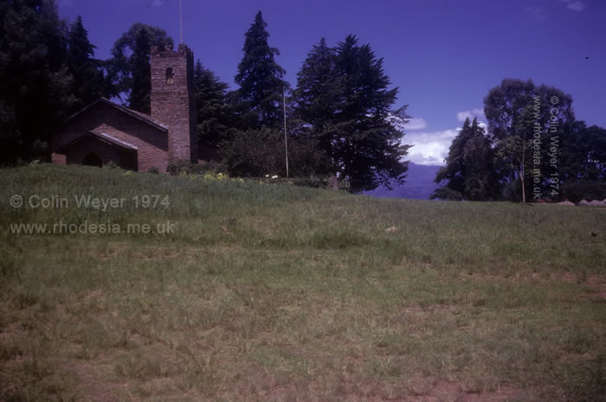
Melsetter village church

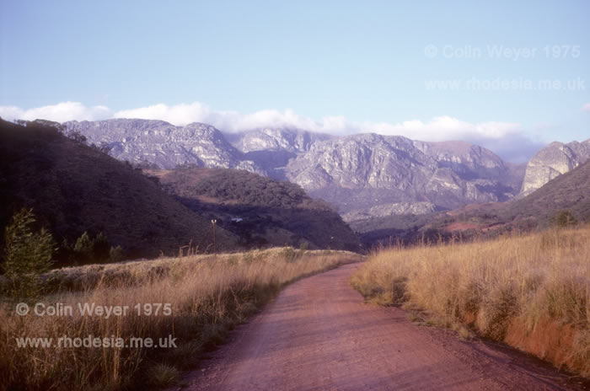
Chimanimani Mountains.
The road to the Outward Bound Camp in the dry season.

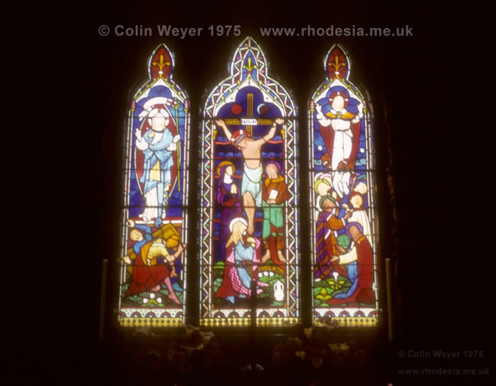
Melsetter Church Window

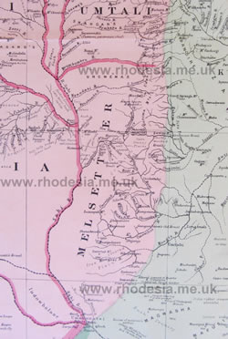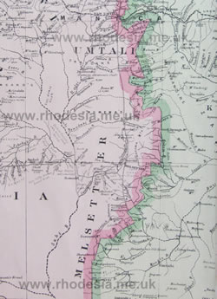
Melsetter District Map 1895 Melsetter District Map 1900
The maps above from 1895 and 1900, at a scale of 1 : 1 000 000, show the Melsetter District when it was first being opened up.
That from 1895 is probably the first ever large scale map of the area and the "road" made by Thomas Moodie is shown as a single line crossing the Sabi at Moodie's Drift and the Tanganda at New Year's Drift before eventually reaching Melsetter Settlement. At this stage most of the boundary with Portuguese East Africa had not yet finally been agreed.
The second map of the same area and scale shows some changes as at 1900:
Notably the building of a road and telegraph line from Umtali to Melsetter village and from there a road to what must then have been an extremely remote BSAP post near where the Mt Selinda Mission was later established.
In 1898 a border agreement with Mocambique had been signed with Portugal at Macequece more or less along present lines. Sadly for Rhodesia in many places the line was to the west of what had been hoped for. The final, present day, boundary was not finally agreed until late 1940.
The other points of interest on both maps are the descriptions which actually well convey the nature of the land concerned. That for the area around the Tanganda River between Middle Drift and New Year's Drift being marked: "Fine Country well watered".
Home

